实验名称 | 内存监视
学号 | 1120141831 | 姓名 | 朴泉宇
一、实验目的
在Windows以及Linux平台下对系统信息、执行信息、内存信息以及对单个进程的监视。
二、实验内容
- 在Windows下编写监视器代码
- 在Windows下编译运行，并监视各项信息
- 在Linux下直接调用系统命令，监视各项信息
三、实验环境及配置方法
- 利用Visual Studio编写Windows下的代码，并编译运行
- 在Ubuntu中用Terminal调用系统命令
四、实验方法和实验步骤（程序设计与实现）
- 编写Windows下的监视器代码
- 思路
此程序整体分成四个模块：
- void ShowSysInfo();
- void ShowPerformanceInfo();
- void ShowPhysicalMemoryInfo();
- void ShowTHISProcInfo();
以及其中void ShowTHISProcInfo();模块调用的以下两个子模块：
- void ShowVirtualMemInfo(HANDLE hProcess);
- void ShowWorkingSetInfo(int PID);
以及为实时覆盖输出的有关控制台光标位置的函数：
- void GetConsoleCursorXY(int &x, int &y);
- void SetConsoleCursorTo(int x, int y);
- void ShowSysInfo();模块：
创建SYSTEM_INFO结构体变量，并调用GetSystemInfo();来实时获取操作系统的各项信息。
- void ShowPerformanceInfo();模块：
创建PERFORMANCE_INFORMATION结构体变量，并调用GetPerformanceInfo();来实时获取操作系统的执行信息。
- void ShowPhysicalMemoryInfo();模块：
创建MEMORYSTATUSEX结构体变量，并调用GlobalMemoryStatusEx();来实时获取当前物理内存的使用情况。
- void ShowTHISProcInfo();模块：
通过Windows自带的任务管理器获取某进程的PID，通过PID获得此进程的HANDLE。
void ShowVirtualMemInfo();子模块创建SYSTEM_INFO和MEMORY_BASIC_INFORMATION结构体变量，并调用GetSystemInfo();和VirtualQueryEx();来实时获取次进程的虚拟内存使用情况。
void ShowWorkingSetInfo();子模块创建PROCESSENTRY32和PROCESS_MEMORY_COUNTERS结构体变量，并调用Process32First();和GetProcessMemoryInfo();来实时获取此进程的工作集情况。
- void GetConsoleCursorXY();函数:
获取当前控制台的光标位置。与kbhit()配合，完成时事刷新信息的功能。
- void SetConsoleCursorTo();函数:
将控制台的光标设定在指定位置。与kbhit()配合，完成时事刷新信息的功能。
- 函数解释
- void ShowSysInfo();模块：
- /*Show System Info*/
- void ShowSysInfo()
- {
- SYSTEM_INFO SystemInfo;
- int X = 0, Y = 0, flag = 0; //Cursor Position

- ZeroMemory(&SystemInfo, sizeof(SystemInfo));

- while (kbhit() == 0)
- {
- if (flag == 0)
- {
- GetConsoleCursorXY(X, Y);
- flag = 1;
- }
- else
- {
- SetConsoleCursorTo(X, Y);
- }

- GetSystemInfo(&SystemInfo);

- printf("Hardware information:\n");
- printf("OEM ID: %u\n", SystemInfo.dwOemId); //1. OEM ID
- printf("Processor Architecture: "); //2. Processor Architecture
- switch (SystemInfo.wProcessorArchitecture)
- {
- case 0:printf("x86\n");break;
- case 5:printf("ARM\n");break;
- case 6:printf("Intel Itanium-based\n");break;
- case 9:printf("x64 (AMD or Intel)\n");break;
- case 0xffff:printf("Unknown architecture.\n");break;
- }
- printf("Page Size(Bytes): %u\n", SystemInfo.dwPageSize); //3. Page Size
- printf("Minimum Application Address: 0x%lx\n", SystemInfo.lpMinimumApplicationAddress); //4. Minimum Application Address
- printf("Maximum Application Address: 0x%lx\n", SystemInfo.lpMaximumApplicationAddress); //5. Maximum Application Address
- printf("Size of Application's usable virtual memory(Bytes): %u\n", ((DWORD)SystemInfo.lpMaximumApplicationAddress - (DWORD)SystemInfo.lpMinimumApplicationAddress)); //Extend. Size of Application's usable virtual memory
- printf("Active Processor Mask: %u\n", SystemInfo.dwActiveProcessorMask); //6. Active Processor Mask
- printf("Number of Processors: %u\n", SystemInfo.dwNumberOfProcessors); //7. Number of Processors
- printf("Processor Type: %u\n", SystemInfo.dwProcessorType); //8. Processor Type
- printf("Allocation Granularity: %u\n", SystemInfo.dwAllocationGranularity); //9. Allocation Granularity
- printf("Processor Level: %u\n", SystemInfo.wProcessorLevel); //10. Processor Level
- printf("Processor Revision: %u\n", SystemInfo.wProcessorRevision); //11. "Processor Revision

- printf("\n*****Press <ESC> to stop.*****\n");

- Sleep(1000); //Refresh per second.
- }
- }
- void ShowPerformanceInfo();模块：
- /*Show Performance Info*/
- void ShowPerformanceInfo()
- {
- PERFORMANCE_INFORMATION PerformanceInfo;
- int X = 0, Y = 0, flag = 0; //Cursor Position

- ZeroMemory(&PerformanceInfo, sizeof(PerformanceInfo));
- PerformanceInfo.cb = sizeof(PerformanceInfo);

- while (kbhit() == 0)
- {
- if (flag == 0)
- {
- GetConsoleCursorXY(X, Y);
- flag = 1;
- }
- else
- {
- SetConsoleCursorTo(X, Y);
- }

- GetPerformanceInfo(&PerformanceInfo, PerformanceInfo.cb);

- printf("CommitTotal(pages): %u\n", PerformanceInfo.CommitTotal); //1. The number of pages currently committed by the system.
- printf("CommitLimit(pages): %u\n", PerformanceInfo.CommitLimit); //2. The current maximum number of pages that can be committed by the system without extending the paging file(s).
- printf("CommitPeak(pages): %u\n", PerformanceInfo.CommitPeak); //3. The maximum number of pages that were simultaneously in the committed state since the last system reboot.
- printf("PhysicalTotal(pages): %u\n", PerformanceInfo.PhysicalTotal); //4. The amount of actual physical memory, in pages.
- printf("PhysicalAvailable(pages): %u\n", PerformanceInfo.PhysicalAvailable); //5. The amount of physical memory currently available, in pages.
- printf("SystemCache(pages): %u\n", PerformanceInfo.SystemCache); //6. The amount of system cache memory, in pages.
- printf("KernelTotal(pages): %u\n", PerformanceInfo.KernelTotal); //7. The sum of the memory currently in the paged and nonpaged kernel pools, in pages.
- printf("KernelPaged(pages): %u\n", PerformanceInfo.KernelPaged); //8. The memory currently in the paged kernel pool, in pages.
- printf("KernelNonpaged(pages): %u\n", PerformanceInfo.KernelNonpaged); //9. The memory currently in the nonpaged kernel pool, in pages.
- printf("PageSize(Bytes): %u\n", PerformanceInfo.PageSize); //10. The size of a page, in bytes.
- printf("HandleCount: %u\n", PerformanceInfo.HandleCount); //11. The current number of open handles.
- printf("ProcessCount: %u\n", PerformanceInfo.ProcessCount); //12. The current number of processes.
- printf("ThreadCount: %u\n", PerformanceInfo.ThreadCount); //13. The current number of threads.

- printf("\n*****Press <ESC> to stop.*****\n");

- Sleep(1000); //Refresh per second.
- }
- }
- void ShowPhysicalMemoryInfo();模块：
- /*Show Physical Memory Info*/
- void ShowPhysicalMemoryInfo()
- {
- MEMORYSTATUSEX MemoryStatusEX;
- int X = 0, Y = 0, flag = 0; //Cursor Position

- ZeroMemory(&MemoryStatusEX, sizeof(MemoryStatusEX));
- MemoryStatusEX.dwLength = sizeof(MemoryStatusEX);

- while (kbhit() == 0)
- {
- if (flag == 0)
- {
- GetConsoleCursorXY(X, Y);
- flag = 1;
- }
- else
- {
- SetConsoleCursorTo(X, Y);
- }

- GlobalMemoryStatusEx(&MemoryStatusEX);

- printf("There is %ld percent of memory in use.\n", MemoryStatusEX.dwMemoryLoad);
- printf("There are %I64d total KB of physical memory.\n", MemoryStatusEX.ullTotalPhys / 1024);
- printf("There are %I64d free KB of physical memory.\n", MemoryStatusEX.ullAvailPhys / 1024);
- printf("There are %I64d total KB of paging file.\n", MemoryStatusEX.ullTotalPageFile / 1024);
- printf("There are %I64d free KB of paging file.\n", MemoryStatusEX.ullAvailPageFile / 1024);
- printf("There are %I64d total KB of virtual memory.\n", MemoryStatusEX.ullTotalVirtual / 1024);
- printf("There are %I64d free KB of virtual memory.\n", MemoryStatusEX.ullAvailVirtual / 1024);

- // Show the amount of extended memory available.
- printf("There are %I64d free KB of extended memory.\n", MemoryStatusEX.ullAvailExtendedVirtual / 1024);

- printf("\n*****Press <ESC> to stop.*****\n");

- Sleep(1000); //Refresh per second.
- }
- }
- void ShowTHISProcInfo();模块：
- /*Show THIS Process Info, includes Virtual Memory Info and Working Set Info*/
- void ShowTHISProcInfo()
- {
- int THISPID = MonitorPID;
- HANDLE hTHISProcess;
- int X = 0, Y = 0, flag = 0; //Cursor Position

- //THISPID = GetCurrentProcessId();
- hTHISProcess = OpenProcess(PROCESS_ALL_ACCESS, FALSE, THISPID);

- while (kbhit() == 0)
- {
- if (hTHISProcess != NULL)
- {
- if (flag == 0)
- {
- GetConsoleCursorXY(X, Y);
- flag = 1;
- }
- else
- {
- SetConsoleCursorTo(X, Y);
- }

- ShowVirtualMemInfo(hTHISProcess);
- ShowWorkingSetInfo(THISPID);

- printf("\n*****Press <ESC> to stop.*****\n");
- printf("*****Close the monitor first, then close The Process.*****\n");

- Sleep(1000); //Refresh per second.
- }
- else
- {
- printf("The Process was not exist. The monitor will close.\n");

- return;
- }
- }
- }
- void ShowVirtualMemInfo();子模块：
- /*Show THE PROCESS's Virtual Memory Info*/
- void ShowVirtualMemInfo(HANDLE hProcess)
- {
- SYSTEM_INFO SI;
- MEMORY_BASIC_INFORMATION MBI;

- ZeroMemory(&SI, sizeof(SI));
- ZeroMemory(&MBI, sizeof(MBI));

- GetSystemInfo(&SI);
- LPCVOID pBlock = (LPVOID)SI.lpMinimumApplicationAddress;

- while (pBlock < SI.lpMaximumApplicationAddress)
- {
- if (VirtualQueryEx(hProcess, pBlock, &MBI, sizeof(MBI)) == sizeof(MBI))
- {
- LPCVOID pEnd = (PBYTE)pBlock + MBI.RegionSize;
- printf("Block starts at: 0x%lx, ", pBlock); //1. Show Block Starts Addr.
- printf("Block Length(Bytes): %u, ", MBI.RegionSize); //2. Show Block's length.
- switch (MBI.State) //3. Show Block's State.
- {
- case MEM_COMMIT:
- printf("Committed, ");break;
- case MEM_FREE:
- printf("Free.\n");break;
- case MEM_RESERVE:
- printf("Reserved, ");break;
- }
- switch (MBI.Type) //4. Show Block's Type.
- {
- case MEM_IMAGE:
- printf("Image.\n");break;
- case MEM_MAPPED:
- printf("Mapped.\n");break;
- case MEM_PRIVATE:
- printf("Private.\n");break;
- }

- pBlock = pEnd;
- }
- else
- {
- break;
- }
- }
- }
- void ShowWorkingSetInfo();子模块：
- /*Show THE PROCESS's Working Set Info*/
- void ShowWorkingSetInfo(int PID)
- {
- PROCESSENTRY32 PE32;
- PROCESS_MEMORY_COUNTERS ProcMemCounter;
- HANDLE hProcessSnap;

- ZeroMemory(&PE32, sizeof(PE32));
- ZeroMemory(&ProcMemCounter, sizeof(ProcMemCounter));
- PE32.dwSize = sizeof(PE32);
- ProcMemCounter.cb = sizeof(ProcMemCounter);

- hProcessSnap = CreateToolhelp32Snapshot(TH32CS_SNAPPROCESS, 0);

- BOOL bNext = Process32First(hProcessSnap, &PE32);
- printf("Process Working Set Information:\n");
- while (bNext)
- {
- if (PID == PE32.th32ProcessID)
- {
- HANDLE hProcess;
- hProcess = OpenProcess(PROCESS_ALL_ACCESS, FALSE, PID);
- GetProcessMemoryInfo(hProcess, &ProcMemCounter, sizeof(ProcMemCounter));
- printf("Commited(Bytes): %u\n", ProcMemCounter.PagefileUsage);
- printf("Working Set Size(Byte): %u\n", ProcMemCounter.WorkingSetSize);
- printf("Peak Working Set Size(Byte): %u\n", ProcMemCounter.PeakWorkingSetSize);

- break;
- }

- bNext = Process32Next(hProcessSnap, &PE32);
- }
- }
- void GetConsoleCursorXY();函数:
- /*Get console cursor's position*/
- void GetConsoleCursorXY(int &x, int &y)
- {
- HANDLE hConsole = GetStdHandle(STD_OUTPUT_HANDLE);
- CONSOLE_SCREEN_BUFFER_INFO CSBI;

- GetConsoleScreenBufferInfo(hConsole, &CSBI);

- x = CSBI.dwCursorPosition.X;
- y = CSBI.dwCursorPosition.Y;
- }
- void SetConsoleCursorTo();函数:
- /*Set console cursor to (x, y)*/
- void SetConsoleCursorTo(int x, int y)
- {
- HANDLE hConsole = GetStdHandle(STD_OUTPUT_HANDLE);
- COORD SetCursorPosition = { x, y };

- SetConsoleCursorPosition(hConsole, SetCursorPosition);
- }
- main函数
main函数起到引导用户选择并使用Monitor的作用。
- int main()
- {
- Restart:
- printf("Please Input the PID to monitor a process.\n");
- printf("If don't want to monitor any process, please input -1.\n");
- scanf("%d", &MonitorPID);

- if (MonitorPID == -1)
- {
- int SelectNum;

- printf("1. Show System Information.\n");
- printf("2. Show Performance Infomation.\n");
- printf("3. Show Physical Memory Information.\n");
- printf("Please input the number to select.\n");

- scanf("%d", &SelectNum);
- switch (SelectNum)
- {
- case 1:ShowSysInfo();break;
- case 2:ShowPerformanceInfo();break;
- case 3:ShowPhysicalMemoryInfo();break;
- default:printf("Input Error!\n");break;
- }

- printf("\nPlease input the command:\n");
- printf("[0] Restart the monitor.\n");
- printf("Other key to close the monitor.\n");
- int command = -1;
- scanf("%d", &command);
- if (command == 0)
- {
- goto Restart;
- }
- else
- {
- printf("Thank you for using.\n");
- }
- }
- else
- {
- int SelectNum;

- printf("1. Show System Information.\n");
- printf("2. Show Performance Infomation.\n");
- printf("3. Show Physical Memory Information.\n");
- printf("4. Show This Process Information, includes Virtual Memory Information and Working Set Information.\n");
- printf("Please input the number to select.\n");

- scanf("%d", &SelectNum);
- switch (SelectNum)
- {
- case 1:ShowSysInfo();break;
- case 2:ShowPerformanceInfo();break;
- case 3:ShowPhysicalMemoryInfo();break;
- case 4:ShowTHISProcInfo();break;
- default:printf("Input Error!\n");break;
- }

- printf("\nPlease input the command:\n");
- printf("[0] Restart the monitor.\n");
- printf("Other key to close the monitor.\n");
- int command = -1;
- scanf("%d", &command);
- if (command == 0)
- {
- goto Restart;
- }
- else
- {
- printf("Thank you for using.\n");
- }
- }
- }
- Linux下直接调用系统命令
- 思路
- 了解Linux的top命令以及打开top之后的P（按CPU使用率）、T（按进程时间累计）、M（按内存占用率）等排序命令。
- 使用ps –A查看所有进程，并找到指定进程的PID。
- 使用top –p PID查看指定进程的情况。
- 使用pmap –d PID查看指定进程的内存使用情况。
- 额外了解htop命令，并对比、使用htop完成如Windows下任务管理器的操作。
- 实验过程略

- 实验结果和分析
- Windows下的实验结果
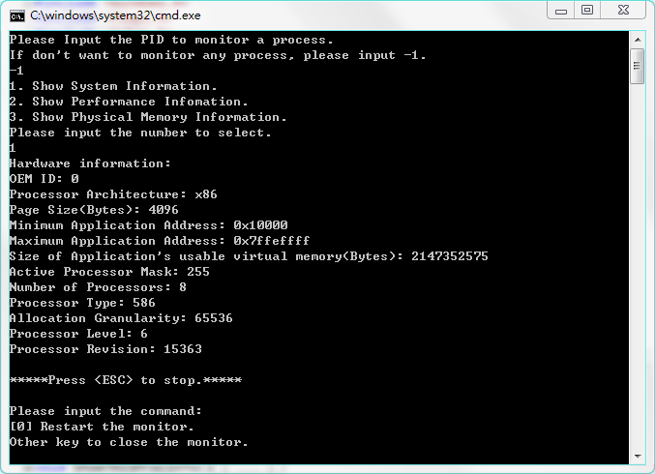
（图1）void ShowSysInfo();模块

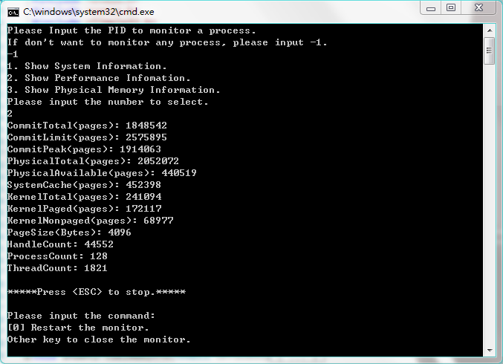
（图2）void ShowPerformanceInfo();模块

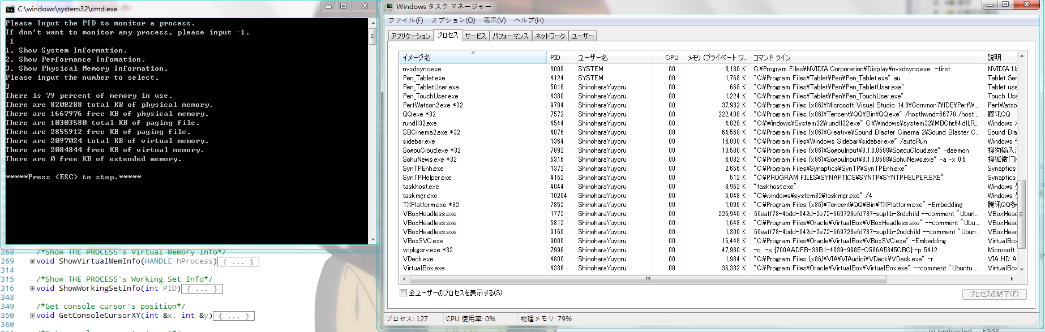
（图3）void ShowPhysicalMemoryInfo();模块

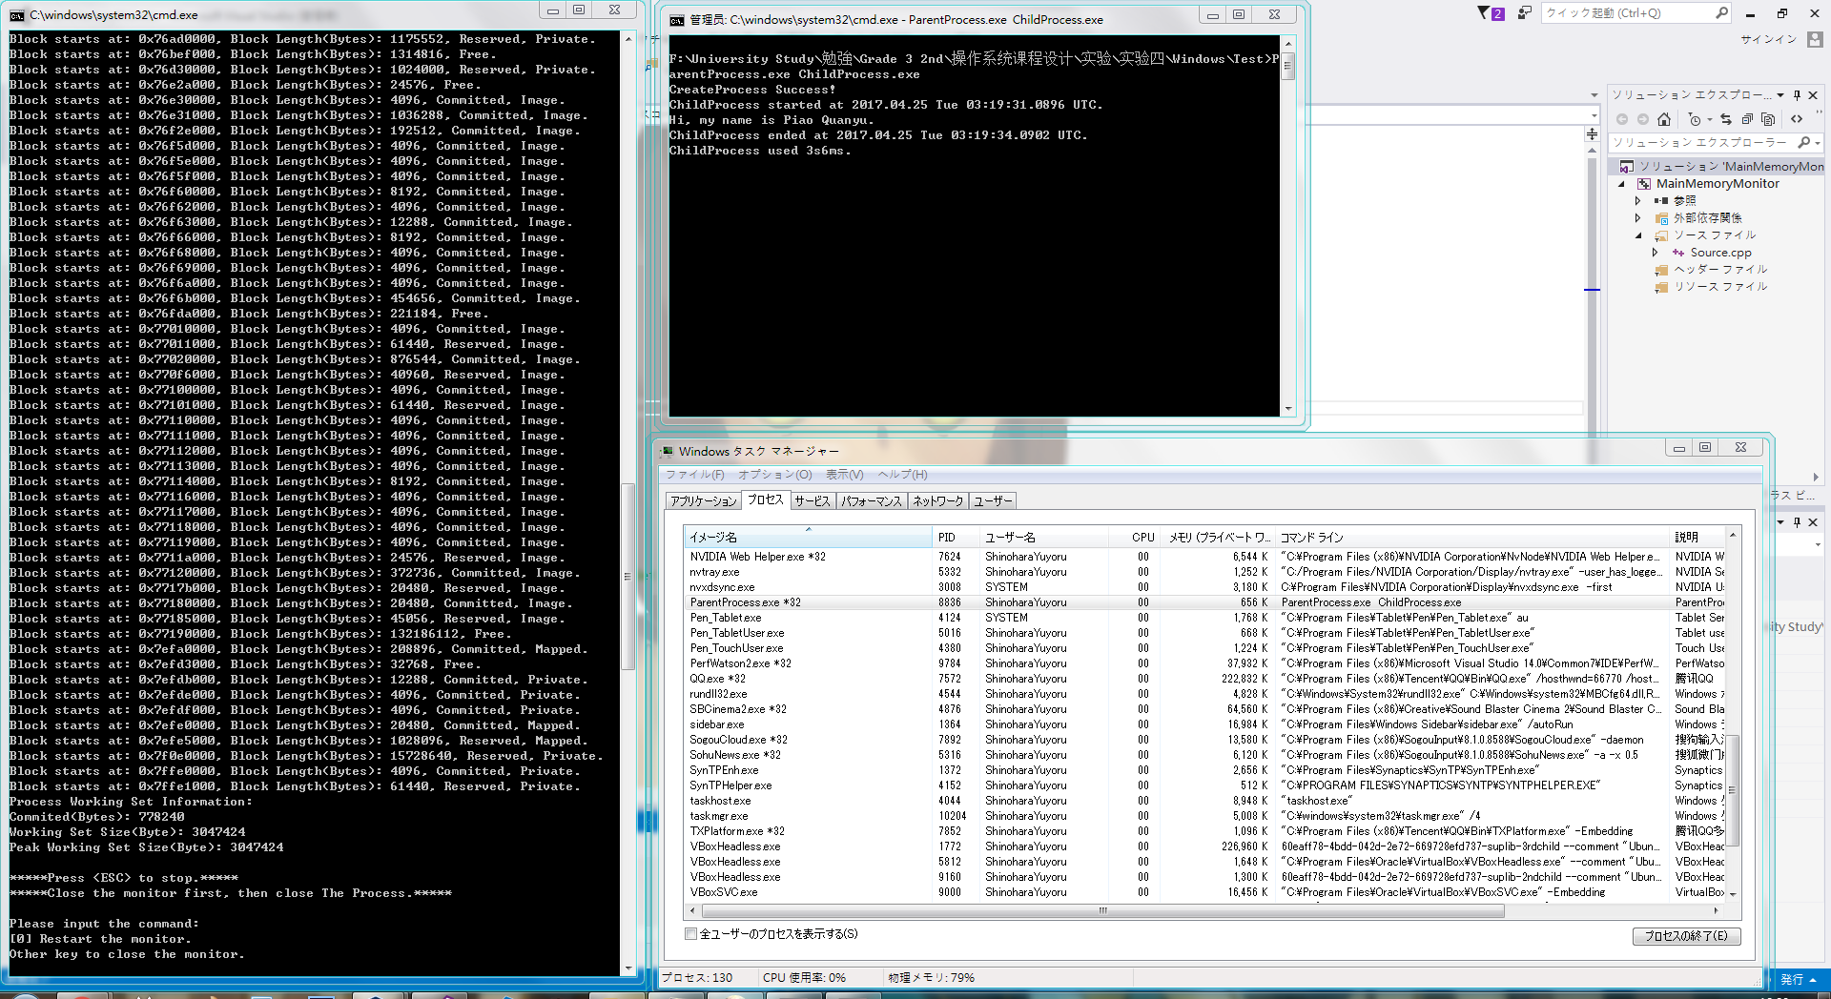
（图4）void ShowTHISProcInfo();模块

- Linux下的实验结果
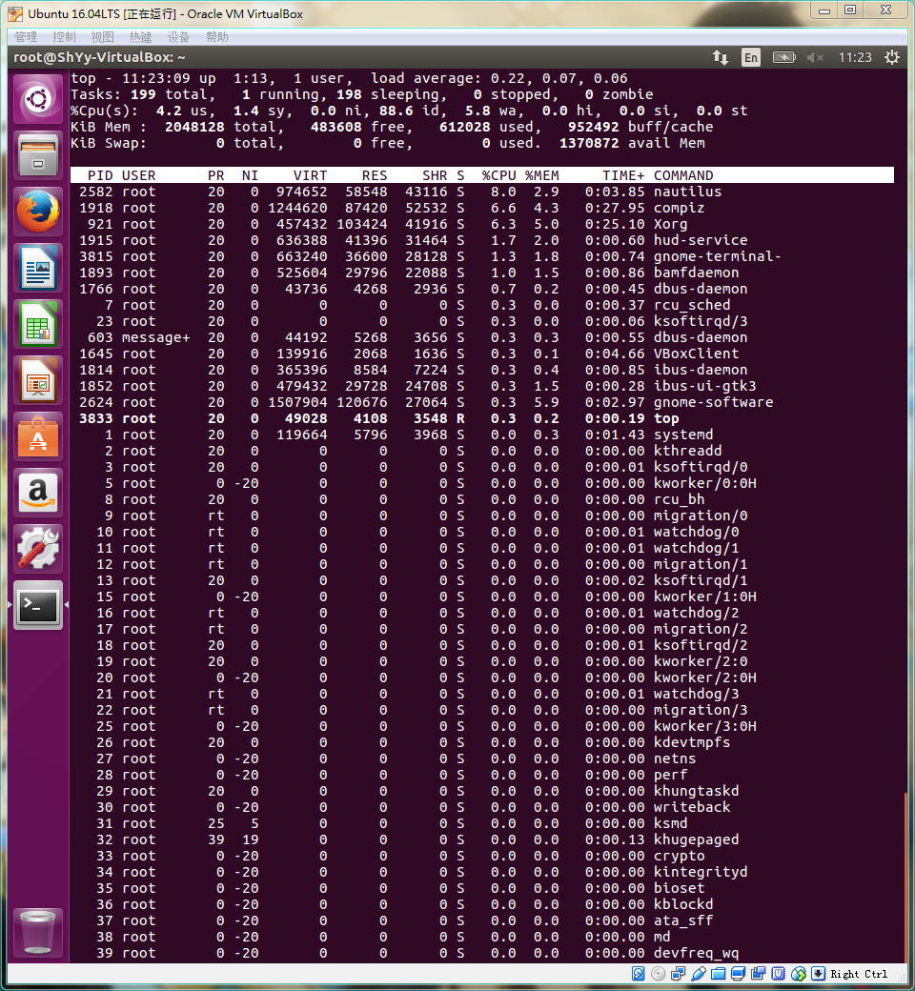
（图1）top命令，P（按CPU使用率）排序

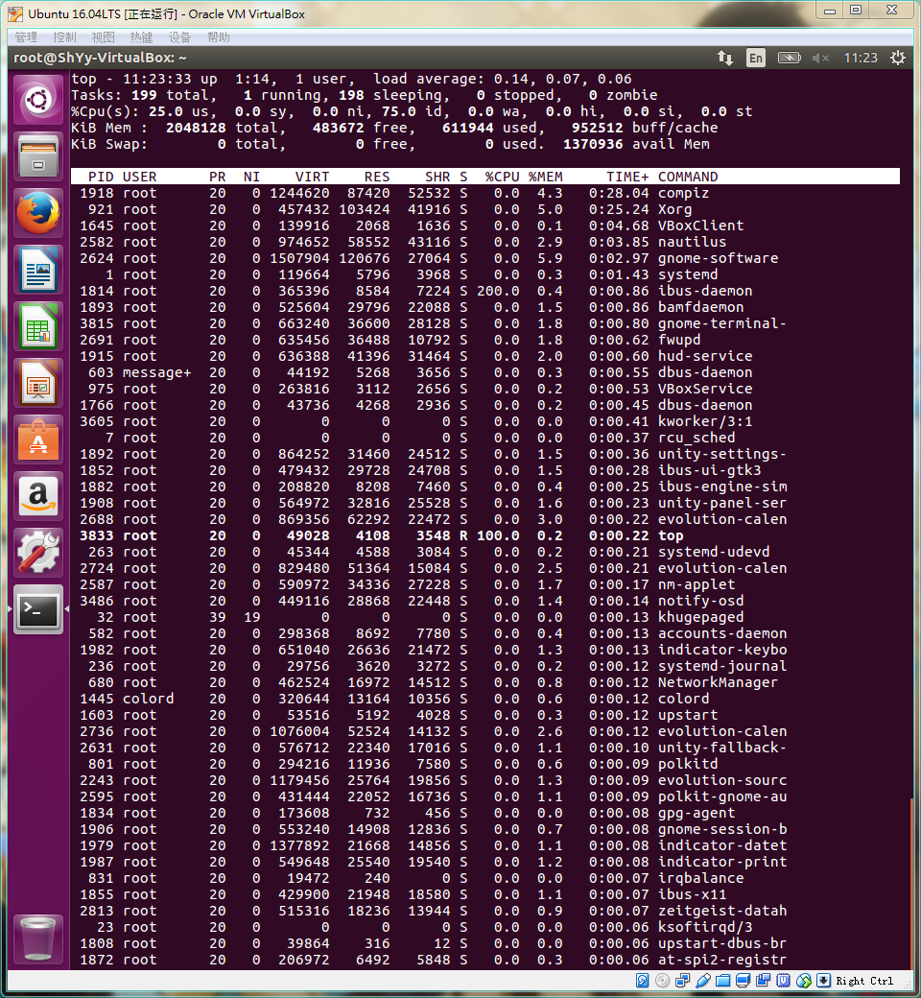
（图2）top命令，T（按进程时间累计）排序

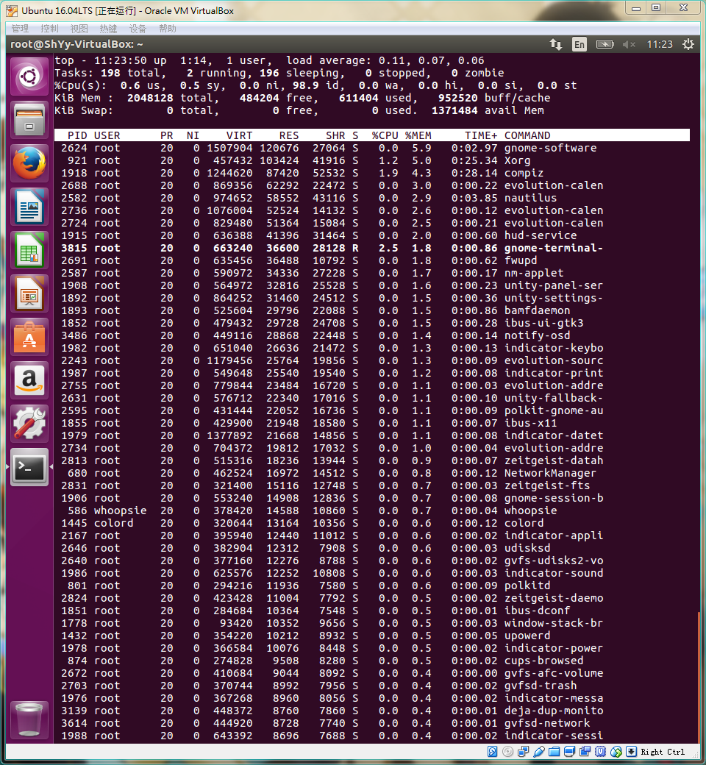
（图3）top命令，M（按内存占用率）排序

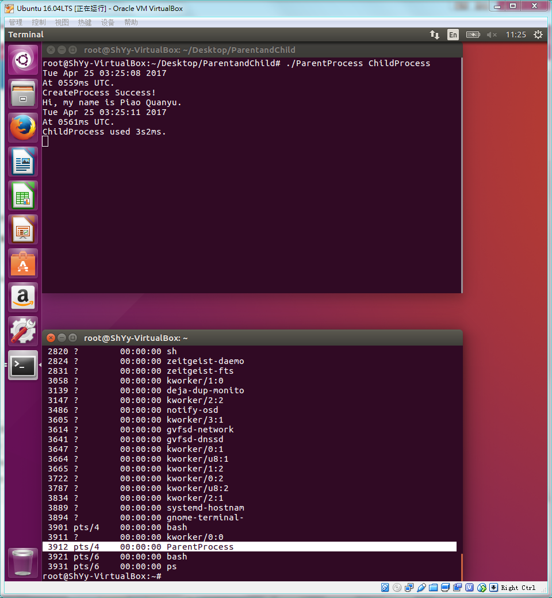
（图4）ps -A命令，查看所有进程，获取到ParentProcess进程的PID

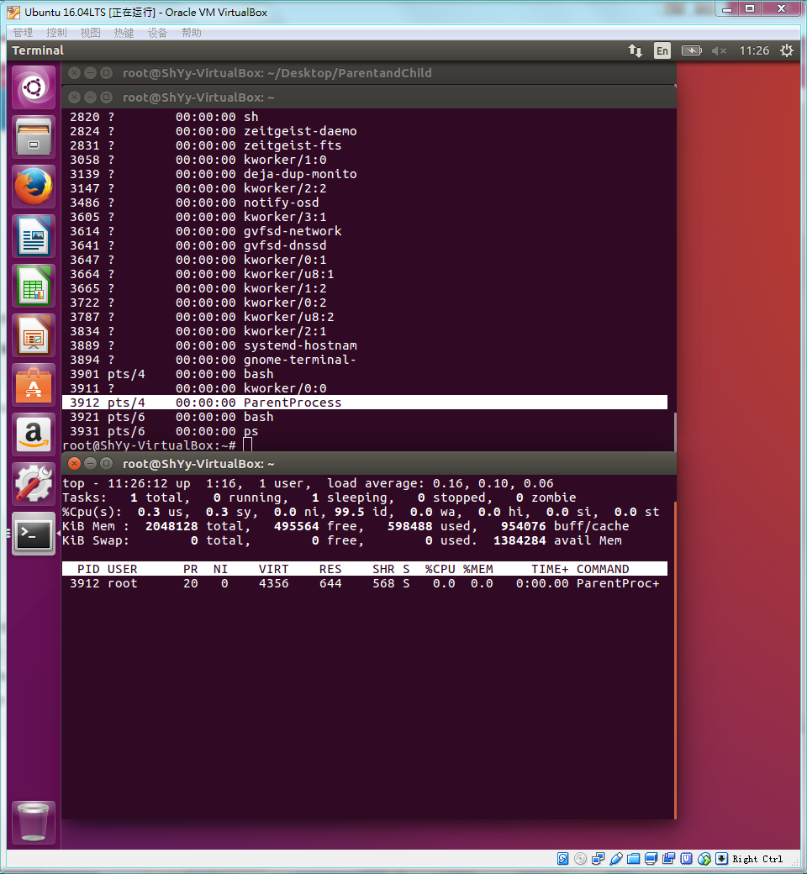
（图5）top –p PID命令，查看ParentProcess进程的情况

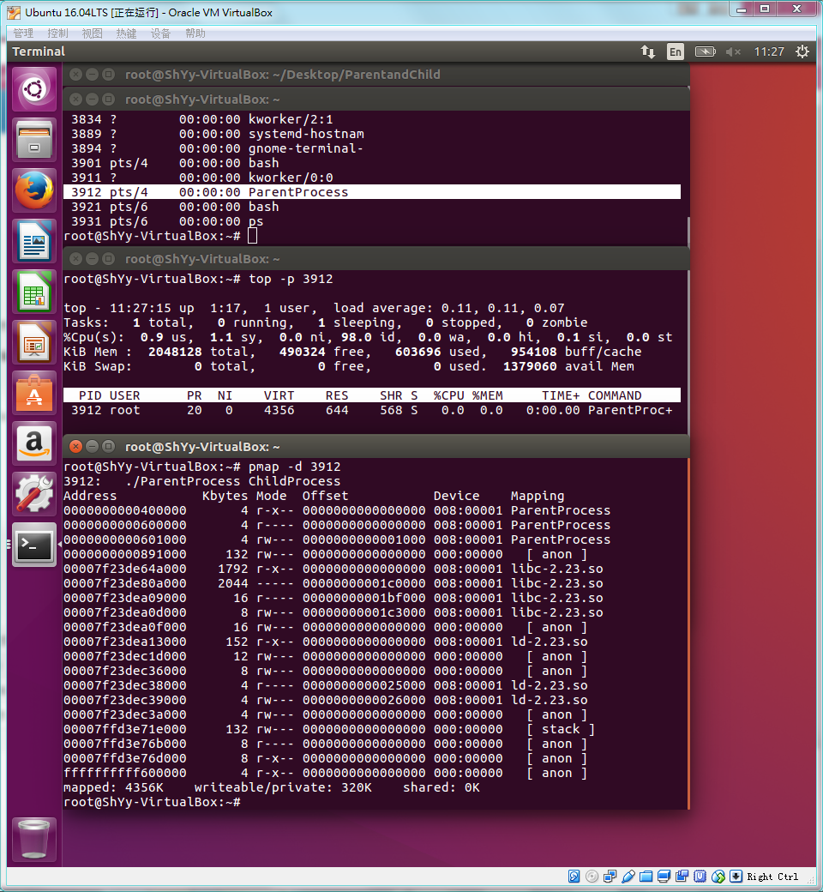
（图6）pmap –d PID命令，查看ParentProcess进程的内存使用情况

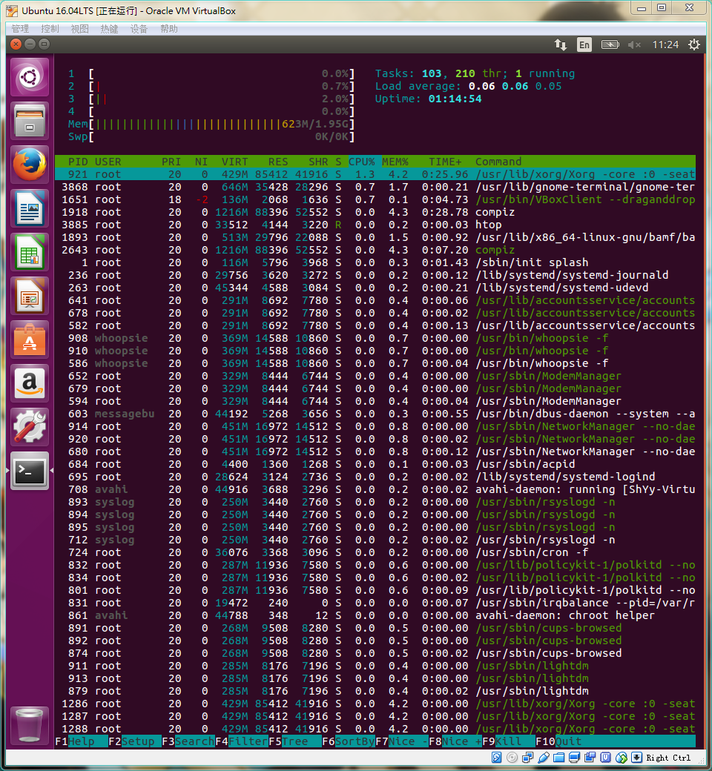
（图7）htop命令

- 讨论、心得
此次实验，模拟了我们在Windows下经常使用的任务管理器，了解了操作系统对进程信息的控制，对进程的操作。对操作系统的内存管理、地址空间布局等概念有了进一步认识。
值得注意的是，此次实验在Linux下并没有编码，但是通过Terminal以及相应的系统命令我们同样完成了与Windows下类似的操作。而且通过简要对比top和htop命令，可以发现htop比top要更加友好、易用。

